Help our planet! | English Lesson
A. Listen, point and repeat.
Word Box

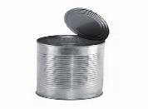
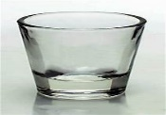
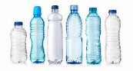
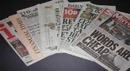

newspaper bottles glass can paper

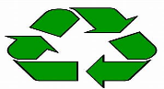
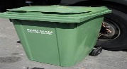
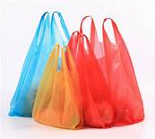
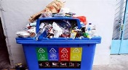

rubbish plastic bag bin recycle

B. Read, listen and match.
A B
1. We read them. a. bottles

2. we write on this. It’s in your notebook. b. bins

3. We put rubbish in them. c. cans

4. They can be plastic or glass. We buy d. newspapers
Water and other drinks in them.

5. They are from the market. We put our e. paper
shopping in them.

6. They are meal. They are used for food f. plastic bags
and drink.

C. Ask and answer.
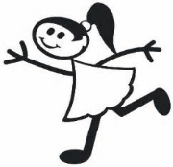
What do you do to save our planet?

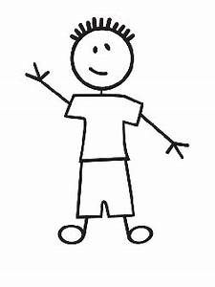
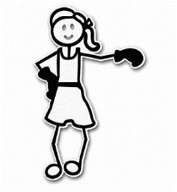

I recycle glass bottles.
I put rubbish in the bin

