**A. Match the occupations with the places of work.**

1. pilot 5. teacher

2. police officer 6. Shop assistant

3. reporter 7. taxi driver

4. Doctor



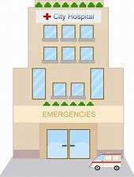

a hospital an airport  a shop a TV station

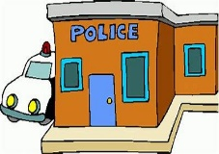

a police station a school a taxi

**B. Ask and answer with your partner.**



She works as a TV station.

She’s a reporter.

What does she do?

Where does your mother work?

May I ask you some questions?

Yes, of course.

**Remember!**

What does he / she do?

He / She is a pilot.