Punctuation Lesson | The Comma
Presentation
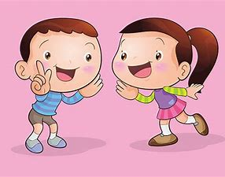
A. Read the conversation
a. What have you got in your bag?
b. I have got a family photo, Kent.
a. Oh, that’s great!
b. These are my parents, brother, myself and baby sister.
a. Yes, you all looked happy.

B. What is the function of a comma (,)?

C. Discussion

We use the full stop (.) to mark the end of a statement.
We use the question mark (?) to mark the end of a question.

Where to use the comma (,)
-We use the comma;
-to separate words or items in a list or series.
Example:
There were monkeys, camels, pandas, birds and horses.
(We use and before the last item.)

-to separate the person or people you address.
Example:
Rosie, what have you got in your bag?
Come here, girls.

-to separate expressions such as oh, well, yes, no.
Example:
The comma marks a short pause in speech.
It makes the meaning of a sentence clearer.
Yes, you all look happy.
Oh, that’s interesting.

