Read Short Stories

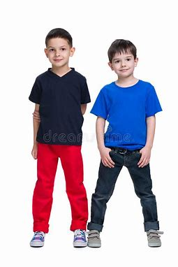
1. MY BEST FRIEND
Jason is my best friend. He is 8 years old. He is taller than me. We go to the same school. We both love playing basketball together. It’s so much fun being with my friend.
Comprehension questions:
1. What is my best friend’s name?
a. Dan
b. Rob
c. Jason
2. How old is Jason
a. nine
b. eight
c. five
3. Which sports do we play together?
a. Volleyball
b. Badminton
c. basketball
4. is Jason shorter than me?
a. Yes
b. No

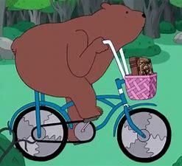
2. Bob the Bear
Bob is a bear. He got a bicycle for Christmas this year. He loves to ride his new bicycle.
He can go very fast on his bicycle. He` sometimes shares his bicycle with his friends.
Questions:
1. What kind of animal is Bob?
a. dog
b. monkey
c. bear
2. What does he love to do?
a. rides a train
b. ride a bus
c. rides his bicycle
3. When did he get his bicycle?
a. on his birthday
b. on Christmas
c. on Thanksgiving
4. Does he sometimes share his bicycle?
a. Yes
b. No

