Sentence Fun Quiz
Directions: Read the sentence and fill in the missing word using the word bank.
log mud sun van dig
bed cat pen bag tub

1. My pig is in the ____________.

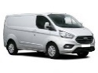
2. I go to the park in a ____________.

3. My dad has a red ____________.

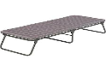
4. I take a nap on my ____________.

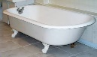
5. I can take a bath in the ____________.

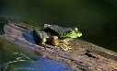
6. The frog is on the ____________.
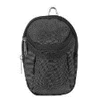

7. My ball is in the ____________.

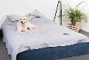
8. The dog is on my ____________.
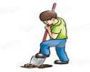

9. My job is to ____________.

10. I see the hot ____________.

