Adjectives for Kids | Language Arts Lesson
This is going to be a lot of fun, today we are going to talk about adjectives:
Let’s start from the beginning. “What is an adjectives?’ We’ll this might sound a little weird. In order to learn this, you have to understand what a noun is.
Remember: A noun is a person, place or thing.
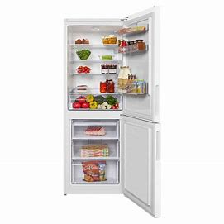
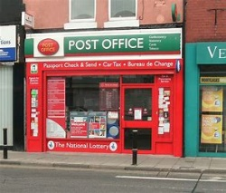

Teacher post office fridge
A person like a teacher, place like a post office or thing like a fridge, if it’s a person, place or thing is a word that’s a noun.
So, here’s where adjectives come in;
Adjectives describe nouns. Adjectives ae words that tell us more about nouns!
So, let’s look at some adjectives for these nouns that we share.
We can use 2 adjectives to describe the teacher; tall and nice
The teacher is tall and nice.
noun adjectives
The teacher is a noun and “tall” and “nice” are adjectives that describe the teacher.
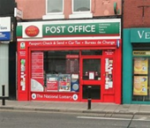
The post office is big and new.
noun adjectives
The post office is a noun and “big” and “new” are the 2 adjectives we used to describe the post office.
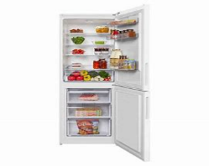
The fridge is large and open.
noun adjectives
The fridge is a noun and “large” and “open” are the adjectives that talks about the fridge.
All the highlighted words you see in 3 sentences describe the nouns. They are called adjectives.
All you need to remember is “adjectives” describe noun.

So, there you go, that’s the end of this brief and simple lesson on adjectives for kids. Hope you enjoyed it, and if you like this video please share, like and let me know your thoughts and questions love to hear from you.

