Final Consonant Sound /f/ as in calf
Look at the pictures.
Say the name of each picture and listen to the ending sound.
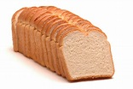
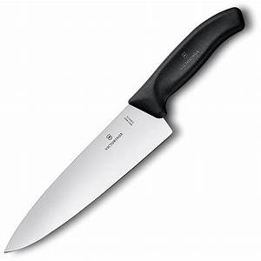

Loaf roof knife
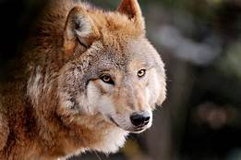
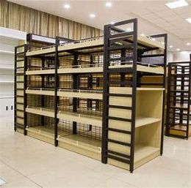

Shelf chef wolf
Ff is pronounced as /f/ as in fish, playful and elf.
Activity 1
Circle the correct word for each picture. Then write the names of the picture in your notebook.
1. leaf half cliff

2. beef sniff chef

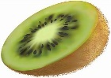
3. loaf half stiff

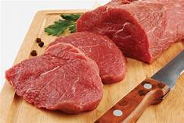

4. leaf cliff beef

5. cliff sniff chief

