Read and Answer || Writing short Paragraph
Read and answer
Hello Evie!
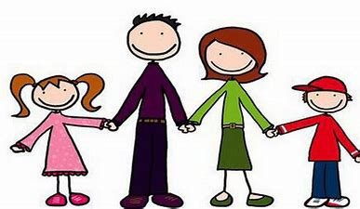
This is a picture of my family. My mum’s name is Helen. She’s librarian. My dad is a fireman. His name is Robert. He loves his job very much. I have got a brother. His name is Tim and he likes computers. We are a very happy family! Write soon and tell me about your family!
Love,
Sharon

A. Answer the questions:

1. What does Sharon’s mother do?____________________________

2. What does Sharon’s father do?_____________________________

3. How many brothers has Sharon’s got? _______________________

4. What does Tim like? ______________________________________

B. Draw a picture of your family. Then write a paragraph like the one above.

Hi,
This is a picture of my family.
___________________________
___________________________
___________________________
___________________________

