Practice saying with your friend, using the following patterns.
Look and
``Practice
- Who is that man?
He’s my neighbor.
Who’s that man
- He is my neighbor?
- Do you know his name?
- No, he I new here.
- He has just moved in that house.
- Do you know how old he is?
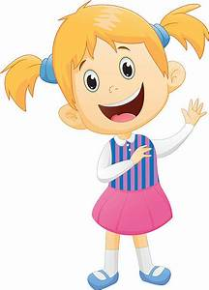
- I think he is the same age as I.
- Have you already met him?
- No, not yet.
- He looks nice.

Oral Drill

Jill and Ron are talking about a newcomer.
Jill: Who is that man?
Ron: He’s my new neighbor. He moved here last week.
Jill: What’s he’s name?
Ron: `Sorry. I don’t know. I have never meet him.
Jill: He looks friendly.
Ron: That’s right. He smiled at me yesterday.
Jill: I would like to know him.
Ron: So. Let’s go and talk to him.

Comprehension questions:
1. Does Ron know his neighbor?
2. Do Jill and Ron know his name?
3. Who looks friendly?
4. Would Jill like to meet him?
5. What are Jill and Ron going to do?

