What Do They Do?
(At work)

In this lesson we are going to talk about the specific work or what they do in a certain jobs / occupation.

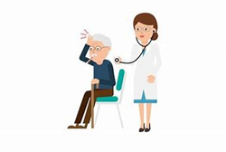

A doctor heals sick people.

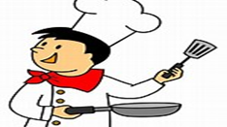

A chef cooks food.

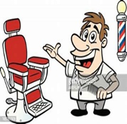
‘

A barber cuts hair.

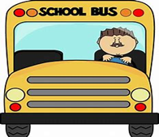

A driver drives a bus or any vehicles.

A shop assistant assists people
in the shop.

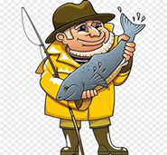
A fisherman catch fish.

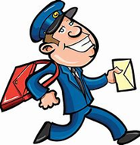

A postman delivers letters to people.

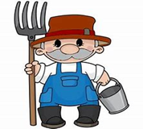

A farmer produces crops, dairy products
and poultry.

A librarian helps people in a library.

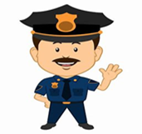

A policeman keeps peace and order.

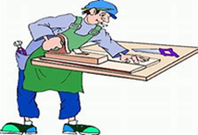

A carpenter builds buildings and houses.

I’ll stop here I hope you understand the work of each job / occupations mentioned above.
Don't forget to subscribe, share, like and let me know your thoughts and questions. Love to hear from you. Thank you.

