Match the sentences with the correct pictures.

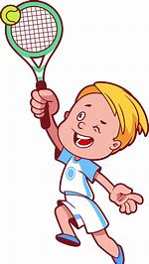
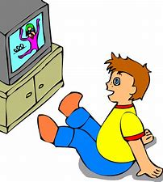
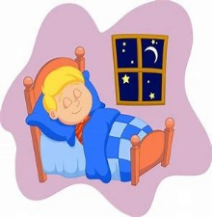
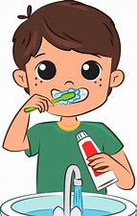
1. 2. 3. 4.

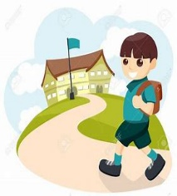
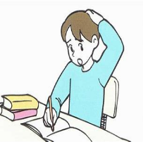
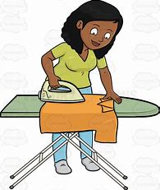
5. 6. 7.

Answers:
a. I go to school. 1. _____
b. I do my homework. 2. _____
c. I play tennis. 3. _____
d. I iron the clothes. 4. _____
e. I go to bed. 5. _____
f. I watch television. 6. _____
g. I brush my teeth. 7. _____

