My Neighbour
This is a lesson for teachers and younger students based on the theme of neighbours /neighbors.
Students will develop their vocabulary and fluency through a range of speaking activities as the course progresses.

Listen and Say
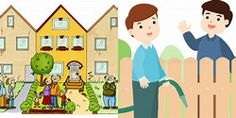
- kind
- nice
- thieves
- friendly
- miserable neighbour / neighbor strong
- excellent friendly and nice healthy
- bad
- dangerous
- ambitious
- clever
- strong
- handsome
- good
- pleasant
- poor tall and thin handsome
- weak
- tall and thin
- short
- healthy
- great
- clear
- clean
- old meet and shake hands
- young
- rich
Note:
- Neighbour: British English
- Neighbor: Canadian and American English
- wealthy
- fair
- honest

