**When to Use the** **Present Perfect Tense | With example sentences**

The present perfect tense connects the past with the present. When using this verb tense, we can be talking about an action or event that occurred in the past but will referring to how it relates to the present.

The present perfect is formed using **has / have + past participle**.

**When do we use the present perfect tense?**

1. to describe an experience

Examples:



He has studied French for two years.

Carl has met the Prime Minister.



I have never been to England

2. to describe a change over a period of time

Examples:

Examples:



Oil prices have increased a lot.



Jake has improved his game since the last time I saw him.



This beauty salon has become very popular.

3. to describe accomplishments

Examples:



Scientists have discovered vaccines for corona virus.



Computers have made students to learn online.

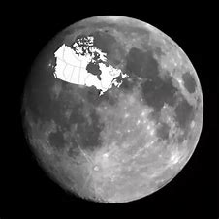

Man has been to the moon.

4. A continuing action that started in the past

Examples:



Mr. Smith has been a teacher here for 5 years.



We have been working together in a hotel for a year.



They have been in the coffee shop the whole afternoon.

So, that’s the end of this lesson and you can find some practice exercises as a follow up to test your understanding on this topic up next.

Don't forget to subscribe, share, like and let me know your thoughts and questions. Love to hear from you. Thank you.