Taking Care of Yourself
It is important for children to learn to take care of themselves in order to keep their bodies healthy and strong. Students will become more aware of the many things we do to take care of ourselves and know that eating well is essential if you want to stay healthy.
Listen and Repeat

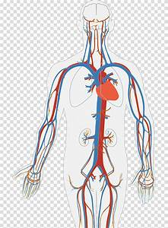
- headache
- have a shower
- happen heart
- guess
- get up kidney
- fever
- earache
- careful
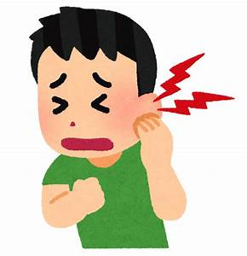
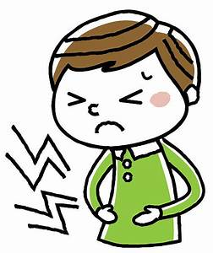
- better
- well
- watch tv
- terrible
- tablet
- stomachache stomachache earache
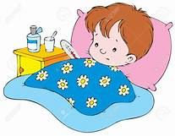
- sickness
- shoulder
- painful
- pain
- medicine
- make a loud noise pain, painful sick, sickness
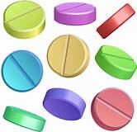
- eat well

medicine tablets

If you want your body to be healthy, you must, look after it.
You must keep it clean.

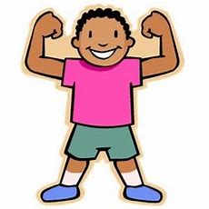

You have to use a toothbrush and toothpaste to brush your teeth.
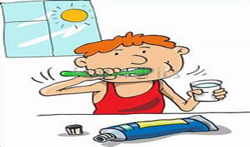
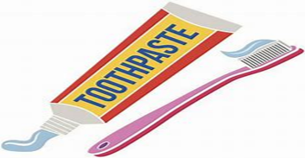

toothbrush and toothpaste brush your teeth

Use soap and towel to clean and wipe your body.
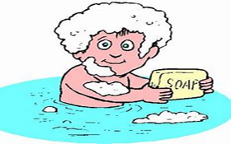
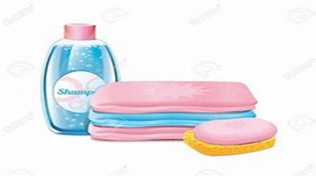

Use a hairbrush / comb to comb your hair.
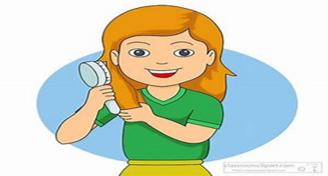
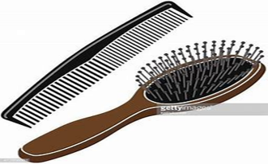

hairbrush and comb comb your hair

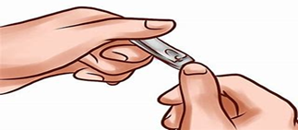
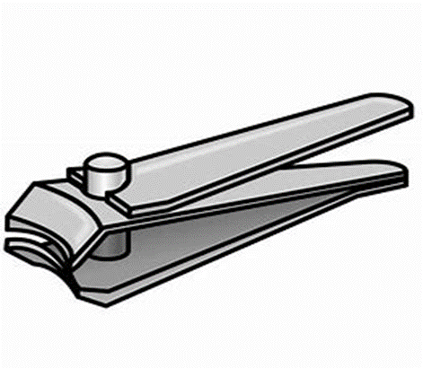
Use a
nail cutter
to cut your nails
and keep them clean.

nail cutter cut your nails

Take care of your eyes by reading in proper light.

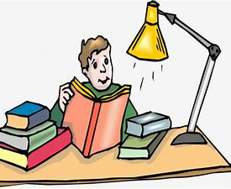

Stay away from loud noises to take care of your ears.
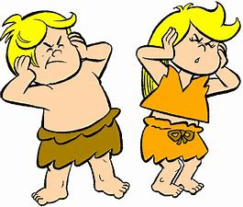

Take care of your stomach by eating the right amount of food
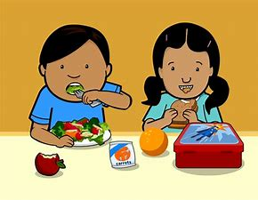

Body needs
- good and clean food at regular interval
- good food helps us grow and makes our body strong
- drinking clean water at a regular interval during the day is very important
- Maintain a correct posture is very important too,
you must always walk erect with your shoulders, neck and hand straight
- sleep is also very important as our body needs rest
- regular exercise is also very important

Summary

- We should take care of our body
- We should keep it neat and clean
- We should eat good food and exercise regularly to live a healthy life.

